GitHub repository: https://github.com/Alaa-Barazi/HwTask

LangGraph Design

State
class AgentState(TypedDict):
user_input: str
sql_query: str
DB_answer: str # a list of row dicts
final_answer: str
maxIterations: int
error_message: str
schema: str
When desgining the graph, the first step was deciding what will be the system’s state. I figured out the basics are : user_input, final_answer, schema and error_message. To prevent infinite loops caused by the agent rerunning multiple time I added maxIterations. DB_answer is used to store what the DB returned after executing the query then the agent will take its value and decide how to construct the final answer which should be human readable. Now when getting the user input its in natural language so it isn’t necessarily a SQL query, for that the agent will create matching one and store it inside sql_query.

Graph Structure
START schema_tool agent ⇄ db_tool End
- schema_tool runs first and unconditionally, since schema is deterministic and always required — there's no reason to route through the agent just to immediately request it.
- agent is a single LangGraph node that internally dispatches between two responsibilities (query generation vs. final-answer summarization) based on state, rather than being split into two separate nodes — since both are genuinely "the agent deciding what to do," not two structurally different responsibilities.
- db_tool executes SQL and always loops back to agent, which decides whether the result is ready to summarize, needs a retry, or ran out of iterations.
- route_from_agent is a single routing function with a sequential decision chain, since the conditions are hierarchical (has a query been generated? has it been executed? did it error?) rather than independent.

Tool Isolation
SchemaTool and DataBaseTool are deliberately separate classes, each with a single responsibility, sharing one SQLAlchemy Engine instance (built once and injected into both). Neither tool depends on AgentState's shape directly , they take plain arguments (a SQL string) and return small dicts that the graph merges into state, keeping schema-specific/DB-specific logic isolated from the agent's decision logic.

Database-Agnostic Design
Both tools use SQLAlchemy's inspect() API and text()/engine.connect() for execution, rather than any engine-specific syntax. This means:
- Schema introspection works identically against SQLite, MySQL, or PostgreSQL no table names or engine-specific system tables are hardcoded anywhere in the code.
- Switching databases requires changing only the DATABASE_URL connection string no changes to other files.
- The LLM prompt for SQL generation is built entirely from the dynamically-fetched schema text, not from any hardcoded table/column assumptions.

Safety: Read-Only Enforcement
Before any SQL reaches the database, DataBaseTool performs two checks:
- Strips SQL comments (so a write statement can't be hidden inside a comment).
- Confirms the query starts with SELECT, and additionally scans for write-related keywords (INSERT, UPDATE, DELETE, DROP, ALTER, etc.) anywhere in the query as a second layer of defense.

Known Limitation: Ambiguous Entity Names
Both Teacher and Student have a Name column. When a question references a name that could plausibly belong to either role (e.g., "What is Alice's average grade?"), the LLM must infer from context which table the name belongs to.
What was tried:
An explicit prompt instruction naming both tables and describing how to disambiguate. This worked for the specific case tested, but hardcoded schema-specific table names into the prompt — which conflicts with the system's database-agnostic design goal, so it was reverted.
Current state:
The system relies on the LLM's general reasoning to resolve this ambiguity, without schema-specific hardcoding. This is not fully reliable — a documented, known limitation rather than a solved problem. A more robust fix would be a dedicated disambiguation step: checking the referenced name against relevant tables before generating the main query, and treating a match in multiple tables as something to clarify with the user rather than silently guessing.

Example Queries and Outputs

Simple Filter + Join
Question: "What courses did Bob take in Fall 2026?"
SELECT c.Name
FROM student s
JOIN coursegrade cg ON s.ID = cg.StudentID
JOIN coursebyteacher cbt ON cg.OfferingID = cbt.OfferingID
JOIN course c ON cbt.CourseID = c.ID
JOIN semester sem ON cbt.SemesterID = sem.ID
WHERE s.Name = 'Bob' AND sem.Season = 'Fall' AND sem.Year = 2026;
Output:
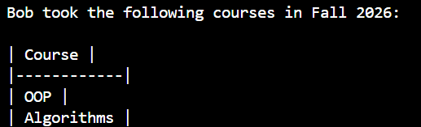

Aggregation Across a Join (Teacher's Average)
Question: "What is the average grade Alice's students received?"
SELECT AVG(cg.Grade) AS average_grade FROM coursegrade cg
JOIN coursebyteacher cbt ON cg.OfferingID = cbt.OfferingID
JOIN teacher t ON cbt.TeacherID = t.ID
WHERE t.Name = 'Alice';
Output:

Multi-Table Join with GROUP BY
Question: "Which teacher has the best-performing students?"
SELECT t.Name, AVG(cg.Grade) AS avg_grade FROM teacher t
JOIN coursebyteacher cbt ON t.ID = cbt.TeacherID
JOIN coursegrade cg ON cbt.OfferingID = cg.OfferingID
GROUP BY t.ID, t.Name
ORDER BY avg_grade DESC LIMIT 1;
Output:

Handling Empty Result (Bug Found and Fixed)
Question: "What courses did Bob take in Spring 2026?" (same query shape as 6.1, filtered to Spring 2026 — Bob has no matching rows)
Output:
This case initially caused an infinite retry loop: DB_answer was correctly [] (empty list, successful execution) but a truthiness check (not db_answer) treated [] the same as "no answer was ever produced," repeatedly retrying an already-correct query. Root-caused via a debug print showing DB_answer: [] | error_message: None looping indefinitely, then fixed by changing the check to db_answer is None, which correctly distinguishes "never executed" from "executed and found nothing."

Out-of-Schema Question
Question: "What are the cheapest hotels in Spain?"
Output:
Rather than hallucinating a nonexistent hotels table or refusing outright, the LLM generated valid, harmless SQL that self-describes the mismatch — grounded correctly in the real schema it was given.

Execution Traces (LangSmith)
Full tracing is enabled via LANGCHAIN_TRACING_V2, LANGCHAIN_API_KEY, and LANGCHAIN_PROJECT environment variables — no code changes to the graph itself were needed.
Each trace shows the complete path: schema_tool agent ChatAnthropic call route_from_agent db_tool agent ChatAnthropic call route_from_agent END, with per-node latency, token counts, and cost. For example, one representative trace (the Fall 2026/Bob question) totaled 5.3s. The system’s own orchestration logic is fast , the latency is inherent to the two-LLM-call architecture, not the graph.
The empty-result bug was diagnosed directly from a trace showing DB_answer: [] alongside a stale error_message from a prior iteration, which made the root cause (a truthiness check treating an empty list as "missing") visible and fixable without guesswork.
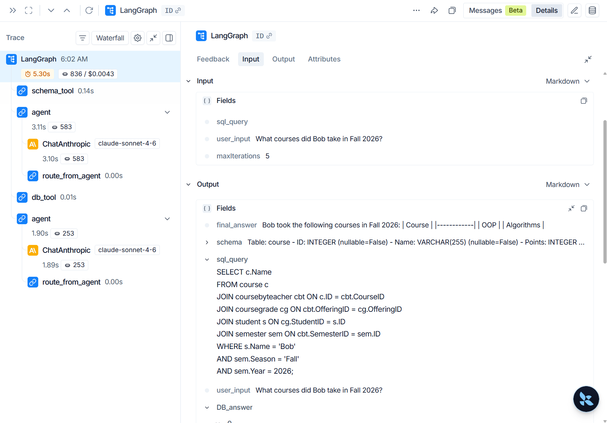
And here is the dashboard view:
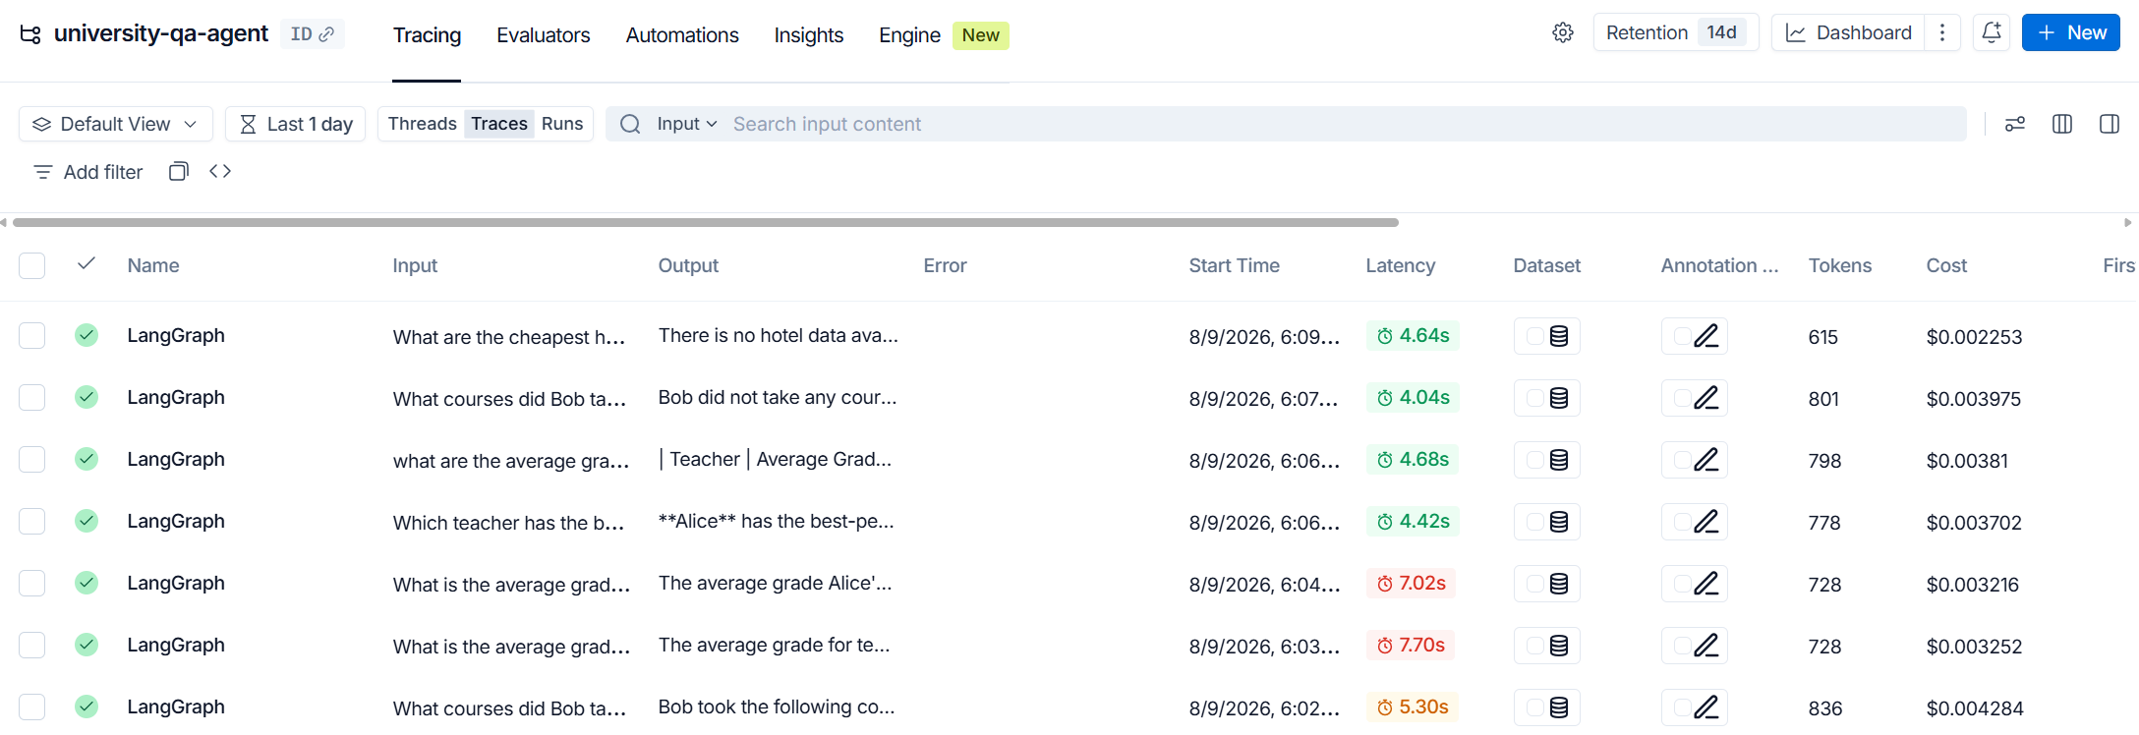

Testing
Unit tests (test_agent.py, run via pytest) cover:
- Deterministic, no-LLM logic: read-only SQL rejection/acceptance (DataBaseTool.execute_sql), and routing decisions (route_from_agent) driven by hand-built fake state dicts.
- End-to-end agent behavior: four real app.invoke(...) runs covering a simple query, a query against a nonexistent semester, a query for a nonexistent entity, and a fully out-of-schema question — verifying the system degrades gracefully rather than crashing or fabricating data in each case.

Production Considerations
Reliability:
Existing retry/error-handling logic is a starting point; production would add timeouts, structured logging, and broader automated test coverage.
Scalability:
Connection pooling for concurrent users; a defined schema-cache refresh policy instead of caching indefinitely.
Monitoring:
LangSmith tracing already provides node-by-node visibility; production would add alerting on error rates and cost/latency dashboards.
Security:
Application-level read-only enforcement is implemented and tested; production would add a database-level read-only role as defense-in-depth, query result limits, and a proper secrets manager in place of a local .env file.
Deployment:
Containerization, a real API layer (e.g., FastAPI) instead of a script entrypoint, and CI/CD running the test suite before deployment.

